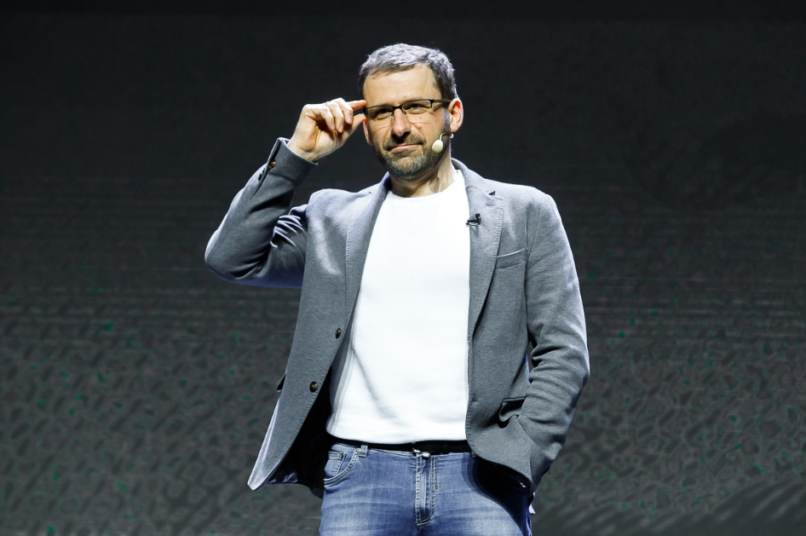

Igor Rybakov is a famous entrepreneur, industrialist, public figure, venture capitalist, and philanthropist, and was featured on Forbes magazine's list of Russia’s richest people.
Igor Rybakov is the author and host of the "Igor Rybakov" YouTube channel, the No. 1 channel about money, investments, and business.
Igor Rybakov is a co-founder and co-owner of TECHNONICOL corporation, which owns 65 factories and 20 learning centers. He is a co-founder of the Rybakov Foundation, which helps develop the social and educational environment in schools. He is also the co-founder of the Equium business club, X10 Academy for "masters of life", and Rybakov PlaySchool schools and kindergartens, as well as the founder and owner of the SOK network of smart offices. He was the EY Entrepreneur of the Year in 2018.
Igor Rybakov is the host of the "Billionaire’s Thoughts" Telegram and Tik-Tok channels, public speaker, and author of the books "Tok", "Thirst", "Teachings of X10 or the Religion of JustYou", "The Secret of X10. Have Something that Gives Everything", "The Seven Wonders of the NetHero" fairy tales for children. Together with Abdulmanap Nurmagomedov (Khabib's father and trainer of 27 world champions), he co-wrote the book "Father". He writes and performs songs, and is creating a music project called RYBAKOV: http://rybakovmusic.com.
Igor Rybakov: "I want all people's prosperity and happiness to grow tenfold, so that at least 10,000 entrepreneurs can become as successful as me! And I will do everything I can to achieve this!"

